Computer classroom manual
How to operate your PC's and servers
By HAND Nepal

Table of Contents
Components of your computer lab 3
Network overview 3
Managing desktops 4
Users and authentication 4
Mapping the shared drive to a drive letter 5
Using the proxy server 5
How the server system works 5
Who may modify the configuration 6
Network shares 6
Proxy server 6
Rachel offline content 7
How backups work 7
VirtualBox: Windows on the teacher's PC 8
Warning 9
How to start the Windows installation 9
Performing tasks on a server system 10
Maintenance: making backups 10
Maintenance: checking status of backups 11
Maintenance: checking system health 11
How to restart or turn off the system 11
How to create a new user 11
How to change a user's network password 12
Changing the network configuration 12
How to install software 13
How to restore backups 14
From the backup to the shared folder 14
Configuration 14
How to open a file manager with full privileges 15
Restoring a failed server 15
Computer damaged 15
Restore system partitions 16
Full restore 17
Windows virtual machine is broken. 17
Error checklist 18
Problem accessing the internet 18
Problem with network share 18
Possible source of error: network problem 19
Possible source of error: password problem 19
Possible source of error: full disk 19
Possible source of error: configuration broken 19
router misconfigured 20
proxy unable to access the internet 20
proxy server not running 20
Backup failed 20
Backup still running or killed, and how to solve 20
Backup failed: no more disk space 21
Failed hard drive 21
General reference 22
Network 23
Operating systems 23
Server Installation 23
Server installation: specific to file server 24
Server installation: specific to backup server 24
After installation modifications 24
File server configuration 25

Components of your computer lab
Your computer lab is composed of:
- a number of computers,
- the software that runs on the computers,
- some thin clients,
- and the network between them.
Each computer has a host name. A host name is the name of a computer, much like a human person has a name. This enables computers to recognize each other on a network (and enables you to keep your computers apart from each other). The computers we installed, have the name of your school in them, an abbreviation of the operating system (“lin” for Linux and “win” for MS-Windows) they are running, and a number.
For an overview of the software used, see page 24.

Network overview
In the diagram below, you can see the main components of a school network. Important notes to make are:
- The switch is the networking device that all other devices depend on for their connection to each other.
- The entire network gets its internet connection through the router.
- The thin clients are grouped by three devices. Two of the devices are conencted to the third one (with a short network cable), the “master” as we call it. The master is connected to the main network. As such, all three clients session run on the same PC. To distribute the workload, we configure the thin clients to connect to different PCs.
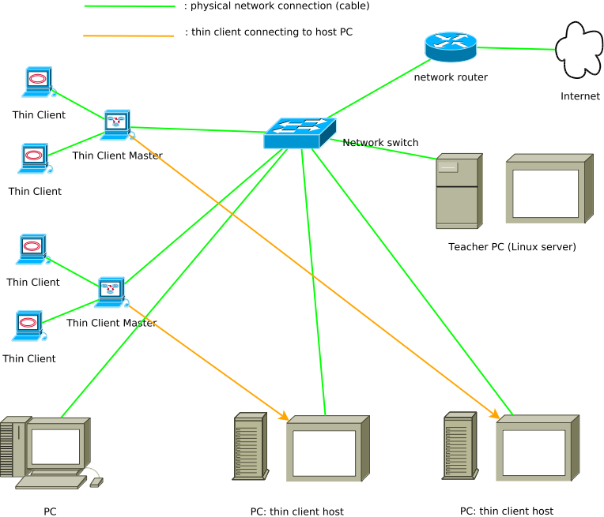

Managing desktops

Users and authentication
The desktop PC's are set up with users called “teacher” which has administrator rights. If you want to install a program of change something in the system, you will need to log on as this user. In order to keep the computer safe from unwanted modifications, virusses destroying the system, etc. do NOT give users access or a password to an administrator account!
Pupils or users who are not supposed to be changing things in the Windows system, must log on using the accounts called “user1”, “user2”, and so on, which have no password. They will be able to use the shared drive, since it is acessible by every computer on the network.
The way in which shares can also be configured is that, in order for a user on a Windows PC to access a share on the server, a user with a fully identical name must exist on the server. Windows will use that password and send it to the server, which checks the password and allows access to the share if it is correct.
For example, if you create a user named “chiniya” on a PC, this user must also exist on the server (if not, the server will reject the user and password, and ask for another one). That is, unless the share is configured to allow guest login (the shared drive we configured allows guest login). If the share allows guest login, then no username or password is needed.
So to sum it up: we set it up with guest logon allowed, with full access to a writeable share. But it would be equally possible to create a new user on the pc's called “pupil” and set the same password everywhere (on all desktops and on the server) and then to allow only this logon to the network share. You could thus deny non-school members access to the share.

Mapping the shared drive to a drive letter
Your users should be able to access the shared folder on the file server. We will do our best to provide a Windows installation that does this by default; here is to do it yourself:
- Search for the hostname of your fileserver. It is the one Linux machine Hand Nepal has installed. You can see it either:
  - in the logon screen on the server, in the upper left corner. It should look like “sharada-lin2” or similar. See the explenation of the naming scheme under “Components of your computer lab” on page 3.
  - when logged on at the server: open “Applications” menu → “System Tools” → “System Settings”, then click “details”.
- Go to “my computer”.
- The toolbar should show a button “map network drive”. Click it.
- Choose “S:” for drive (Shared) and in “folder”, type “\\serverhostname\shared” (substitute “serverhostname” with the hostname of your file server).
  - For the teacher, you will also want to bind “H:” to “\\serverhostname\teacher”.
- Leave the box “Reconnect at logon” ticked.

Using the proxy server
The proxy server is also running on the fileserver. If you configure a web browser on a desktop, configure the proxy server address for http with this url: http://192.168.123.11:3128 .
If you change the address of the file server, you should also reconfigure the web browsers to use this address!

How the server system works
The operating system (OS) installed on the servers is Ubuntu, version 12.4. Ubuntu is a version of Linux. Ubuntu is an operating system free to use and modify (open source software, or free software).
Under Linux, some things function somewhat different than with Windows, others work in a similar way. For example, there are applications with which you can edit text files or manage files, but they look and feel a bit different from their Windows counterparts. Another difference is that Linux does not know drive letters in “my computer” like Window: everything is in the same hierarchy and starts with a “/”. Your personal folder will always be a subfolder of /home (/home/administrator). Most other folders are system folders and need not to be managed directly.
There is documentation available on how to use the desktop by selecting “applications” (a menu at the top of the screen) → “accessories” → “help”.
We installed one server system for the following purposes:
- A proxy server called “Squid” is for saving user files and speeding up web usage. Every user's web browser should be configured to connect to te proxy server instead of accessing the web directly. It will provide a considerable improvement on web surfing speed.
- A file sharing software called “Samba” is providing access to a network share. Windows PC's can access it over the network. A Windows drive letter can be assigned to them.
- We also provide access to an offline content system called “Rachel”. It works with a web server, the same way as surfing the world wide web, but without the need for an internet connection.
We configured one of your Windows desktops as a backup system. It can be used to make regular copies of user data. In case the file server has a problem or data gets lost (software errors, virus, mistakes such as accidentally deleting a file,...) the data will still be safe on the other system.
It is extremely important to make regular copies of the data! A procedure is provided on page 10.
For safekeeping, multiple copies of your data are retained. This in case the disappearance or corruptions of a file goes unnoticed for some time, or to restore an older/better version of a file or folder.

Who may modify the configuration
In Ubuntu, one user (at least) has the rights to change the system. In our servers, we have named him “teacher” (in lower case). When he tries to change something in the system, the computer will ask for his password. It is important that you remember this password, and keep it in a safe place. If someone who should not change the system gets to know the password, you should change the password. Use a password that is not easy to guess by a person. Ideally it should be 8 characters (letters or numbers) long and contain both lowercase and uppercase letters, and a few numbers. Example: “ga46GD2f” (without the “”).

Network shares
A server software called Samba is installed on the fileserver which allows Windows PC's to connect to a network share. It will be visible in the network neighborhood (inWindows Explorer, click “network” on the left of the window). Users have access to a share (this is a shorter name for “folder shared over the network”) called “shared” which all users can access and in which everyone can read, write and delete files and folders

Proxy server
A proxy server is a service in between a web browser (Firefox, chrome...) and the Web. When a user downloads a file or surfs to a web page, the proxy server will save the file. The next time someone accesses the file, the proxy server will provide the saved version. This can save bandwidth and speed up internet (web) usage. In our system, almost 50 GB of disk space is reserved for caching (=keeping a copy of) web files. In order for this to work, the browser must be configured to use the correct address and port of the proxy server (see “Using the proxy server” on page 5).

Rachel offline content
Rachel is the name of a project which aimes to provide educational content and tools from a wide variety of sources in such a form that it can be published on a local network – literally within the walls of your school. Rachel is a website on your own network, which can be used without having to be accessed over the internet (which may be unavailable, and will in any case be a lot slower).
You can access Rachel on the URL: http://192.168.123.10. Notice that a search engine is available at the top of the screen. Rachel provides educational material like video's, statistics, and an offline version of Wikipedia for Schools, but also interactive tools like typing tests.
Since Rachel is dozens of GB in size, downloading all of in on an average internet connection would take a week or more.

How backups work
We have provided a method of backing up the shared files on the file server in a reliable way. There are dozens of possible ways to perform backups, but we have chosen this one because:
- it is safe: it uses a “pull” method, which means the backup server copies data from the file server, not the other way around; this implies that only people with access to the backup folder on the backup computer can ever do harm to the backed up files.
- It is reliable: when a backup is done, it is easy to see if the backup has succeeded or not
- a backup can be made with a few mouse clicks
- it is fast: only modified files are copied, yet in a backup folder you can see the exact same situation as existed on the file server at the moment the backup was taken.
One of your Windows PC's is a backup computer. It copies files off the network share and saves it on its own drive.
Everything described in the next paragraph happens on the PC used as backup.
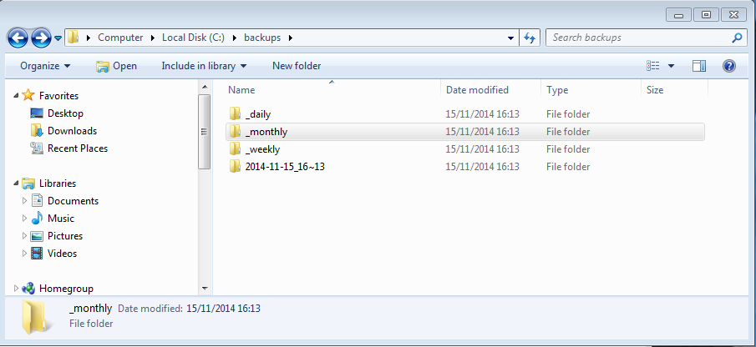
The backups are stored in c:\backups. In this folder, there are subdirectories named after the current date and time. The c:\backups folder is only, and should only be, accessible by the teacher!
Each time a backup is made, a folder with a name like “2014-11-15_16~13” is created. This signifies the date and time the backup was created (15th november 2014, 16:13). A folder name which starts with a tilde (~) means an imcomplete backup, or one that is still running. Be careful not to mistake an incomplete backup for a real, succesful backup! See also page 11.
After a day after your first backup, the backups will start appearing in the “_daily” folder. The backup program will keep one new backup in this folder per day, maximum. The same thing will happen for _weekly and _monthly: if more time than a week, respectively a month, has elapsed since the last weekly, respectively monthly backup, it will put a backup in these folders, too. This way you are guaranteed to have backup copies at regular intervals, for a guaranteed period of time (which we set to 8 weeks).
Very important to know is that the backup will save files located on the network share exclusively! That means that the shared drive and the teacher's home folder on the server will be backed up. Files on the other PC's in the network will NOT be backed up! So you are encouraged to save all your work on the file server, and back it up regularly.

VirtualBox: Windows on the teacher's PC
VirtualBox is a piece of virtualization software. A virtualization program is a program that mimics or simulates a real computer. Virtualization is extremely popular in modern computing! It tricks a normal operating system (Linux, Windows, or others) in thinking that it runs on a normal computer; instead, the entire system you would normally see on the computer screen is visible inside a window on your desktop.
We installed VirtualBox on the Linux server, together with a complete installed Windows 7 system and the same programs that we installed on the Windows PCs in your school. This way, you can have the benefits of having a Linux server and applications, as well as being able to access the same kind of system and applications the students can use.

Warning
Like a real, physical computer, the virtual Windows installation needs some of the memory of the host PC (your Linux computer), and also a “virtual” hard disk. The hard disk is a large file on your Linux system, which becomes the disk of the virtual Windows PC. The disk is saved in the teacher's home folder, under “VirtualBox Vms”. Do NOT EVER change or remove any file in this folder!

How to start the Windows installation
Click “Applications”, “Accessories”, then “VirtualBox”. You should see a window like this:
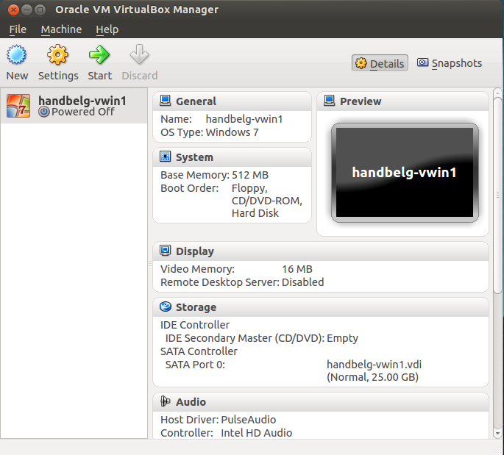
The virtual machines are listed on the left (you only have one). Simply click on the name or icon, click “start” in the toolbar, and your machine should start its bootup procedure just like a normal PC. You log on to it, access the same network shares and use the same programs as the PCs or thin clients in your computer class.

Performing tasks on a server system
In this section we describe various small tasks you may need to perform on your computer systems. The first ones, whose title start with “maintenance”, should be performed on a regular basis. For example, it is advisable to make a backup at least once or twice a week, and to verify that the backup succeeded.

Maintenance: making backups
To make backups, you can use one specific Windows PC in your computer room. How to recognize which PC is intended for backups?
- It has an icon on the start menu under “Programs” that says “BACKUP” or “rsyncbackup”.
- It has a folder c:\backups with a lock next to it, and a folder c:\rsyncbackup,where the backup program lives.
It is advisable to read the section on how the backup system works on page 7!
- Make sure your file server (the one that runs Linux) is on, completely started (you don't need to log in), and connected to the network.
- Start your backup PC
- log on to the backup PC as “teacher”.
- Check that you have both “H:” and “S:” drives
- To create a new backup, go to Start → Programs → make backup. A terminal window (a text window with white text on black background) will show up.
The terminal window will show up for some time while the backups is in progress. This may be short time if there are not many files on the file share, or not many that are modified, or a longer time if you are already storing a lot of shared files. In normal circumstances, it will copy all new files and create a new backup snapshot in c:\backups.
Important: as stated previously under “How backups work”, the backup program will make copies of the contents of the file shares ONLY. NO data on the PC's themselves are backed up!
When the terminal disappears, look in the c:\backups folder to see if there is a new folder “yyyy-mm-dd_hh~mm” (meaning: the year, month, date, hour, and minute when the job started).
How to recreate the menu shortcut if you lost it:
- open c:\rsyncbackup in Windows Explorer
- drag and drop the file “rsyncStart.bat” to the desktop using the right mouse button.
- A context menu will pop up, choose “create shortcut here”.
- Click the Start menu
- Right click on “all programs”
- choose “open”; an explorer window will open
- drag the shortcut from your desktop to that window
- It should now appear in the start menu.

Maintenance: checking status of backups
You are strongly advised to read the section on how backups work, which can be found on page 7.
The most recent backup will be one on the c:\backups folder with the most recent date+time in its name. This should ideally only a few days.
If you see a folder ending in a tilde (~), this can mean two things:
- a backup is still running. Take no action, just wait until the backup finishes. The backup script will rename the directory (removing the tilde from its name) and you will again have a full, recent backup.
- a backup has failed and has stopped halfway. If you don't see a terminal window with white text on a black background anywhere on your computer with “backup” in its title, your backup jobs has very likely been interrupted halfway and did not have the chance to end properly.
If you started the backup manually (in the start menu), it is easy to see if it is still running or not. A scheduled backup, on the other hand, runs in the background. You need another way to verify if the script is still running: by using a task manager.
- TODO
- ... See the troubleshooting aid on page 11.

Maintenance: checking system health
The two components in any computer that are likely to fail first are the power supply and a hard disk. Power supplies can simply be replaced; hard drives contain data and therefor they should be looked upon regularly (once every two weeks, or once a month).
You can do this using the Disk Utility (Application Menu → System Tools → Preferences → Disk Utility). You will see “500 GB Hard Disk” or something similar, on the left. Click on the disk and check the status next to “Smart Status”. It should say “healthy”, with a green indicator light.
If it doesn't, call a technician for help. Your hard disk may fail soon!

How to restart or turn off the system
In the upper right of the screen (in the task bar) there is an icon that looks like a gear wheel. This shows a menu with the most important system tasks. There is a “shutdown” item. If there are users logged in, you need to provide the teacher's password. This is a protection against inadvertedly closing other people's session. Normally, you (the teacher/administrator) would be the only person logged in to the system.

How to create a new user
This procedure describes how to create a new user in order to allow him or her access to the shared network drives. IMPORTANT:
- the network shares are defined on the fileserver, so it is only necessary to create users on the fileserver.
- Like we set the system up, you don't actually need to do this, since all computers are allowed to connect to the shared drive, and the shared folder is writeable by everyone. However, different people in the school might want a personal drive of their own.
How to create a user:
- go to Applications → system tools → administration → users and groups.
- Click “add”.
- enter the user's details and create a password.
- the username should just be lower case letters and maybe a few numbers.
- A new user only needs to be a normal user. Do not make other people “administrator” (except, off course, you explicitly want another account on the system with more privileges)!
You now created a user on the system. An extra step must be taken in order to allow the user access to the network shares: (s)he needs to be given a network password: see next section.

How to change a user's network password
This procedure changes the password a user can use to log on to the server in order to access a network share with restricted access. It can be the same as the password that this user logs on to the Linux desktop with, but for technical reasons, they have to be maintained separately.
- Go to applications → system tools → administration → samba.
- Take the menu Preferences → Samba Users.
- Here, you can change the user's network password.

Changing the network configuration
The network configuration can be modified when logged on at the system; there is an icon at the right of the bar at the top of the screen. It looks like an up/down arrow when connected. And like this when not connected:
It is configured as described in the section “Network“ on page 23.
If you change the address of the fileserver, you will need to:
- Map the network drives again, if they are using the IP addresses again (see page 5).
- Reconfigure the user's web browser to use the new address as proxy, since the proxy server is running on the Linux server.
- Recreate all bookmarks to Rachel that you may have made.
- Reconfigure your internet router, since it determines that only the Linux server can directly access the Web. The router does not block or allow computers, it blocks and allows network (IP) addresses. f you change your server's address, the router will allow and block the wrong network addresses.
Everything considered, it is best to leave the server's IP address as it is!
Do not forget: in order for the Linux server (which also means: the proxy server) to access the internet, you need to set the correct default gateway and dns addresses on the “fileserver” system. You can find what these are by inspecting the network status on a Windows PC. Off course, you only need to do this if your network is being reconfigured, and the network addresses in the router have changed. Your support person should be able to help you with this.

How to install software
Installing some new program in a Linux system is easy. Most of the freely available (open source) programs are part of the Ubuntu operating system. They can be automatically downloaded and installed as follows:
- Log in to the Linux computer qs “teacher”.
- click the “Applications” menu, “System Tools”, “Administration”, then “Ubuntu Software Center”.
- You can browse through the categories on the left hand side, or use the search enfine at the top right.
- You will notice that sometimes, paid-for programs are listed too. For most tasks it is possible to find a functional open source program, though.
- When you made your choice, click the program, and click “install” on the right.
- A progress bar will apear on top of the “install” button while your software packages are automatically downloaded and installed.
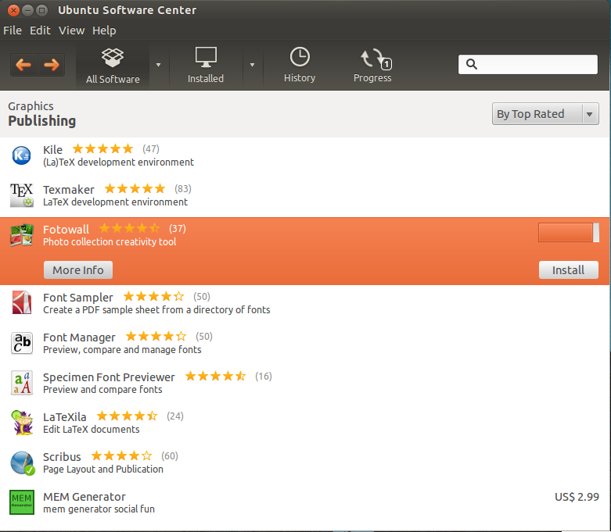
- After the installation, you will notice the “install” button was replaced by a “remove” button.
- The program will show up somewhere in the “applications” menu.
For more details, see the item “Ubuntu Software Center Help” under the “help” menu in Software Center.

How to restore backups
By “restoring backups” we mean putting a file or folder, or even the entire contents of the shared drive, back in its place after it has been damaged or lost.
Users make errors, hard disks may fail. But even if your Linux server fails and has to be re-installed (by a technician), you will still be able to put the data back in place!

From the backup to the shared folder
- Log on as “teacher” to the Windows PC which serves as backup computer.
- Open the c:\backups folder in windows Explorer as described in the section “How backups work” on page 7.
- Also open the shared drive, which should be the S: drive in “my computer”. For more information on how to map the S: drive to the shared folder on your Linux file server, see “Mapping the shared drive to a drive letter” on page 5.
- In case you only lost some files:
  - Open your most recent backup. Try to find the file you lost. The folder structure in the backup will be the same as your shared drive.
  - If you can't find it in the most recent backup, try an older one. It may be so that the file got deleted some time ago, and you have taken several backups since that moment (the file will not be present in the latest backup folder(s) anymore!
  - You may have to go back to the backups in the folder _daily, _weekly, or _monthly. Try to find the latest version of the file before it got deleted or disappeared.
  - You can simply drag and drop the file back to the shared drive.
- In case the Linux file server had a serious error and ALL data are lost:
  - Make sure that data was actually destroyed; if the Linux server is still working properly, you can see in the folder /home/shared on the Linux server. This is where the shared drive can be found.
  - Open your most recent backup folder next to the shared drive.
  - Select all files and folders in it, and drag and drop the whole thing into the empty shared drive on your repaired file server.
WARNING: be careful not to overwrite or change the contents of the backups folder!

Configuration
On the Linux server, the most crucial configuration files extra have safe copies in the “Documents” file of the teacher. Since this folder is backed up together with the shared folder, you have several copies going back in time in case of accidental removal.

How to open a file manager with full privileges
TODO remove this section?
Despite the fact that you, the administrator, has the rights to modify the system, this is only possible after a program has asked you for a password. The program will then switch to more elevated access rights.
The Nautilus file manager (which is opened if you click any entry in the “places” menu) only has rights to files an folders that are owned by “administrator”, or have access rights set (such as: everyone can write the file or folder).
This means you can normally never change the actual system files directly, which makes the system a lot safer to operate. In case you still need to modify a system files (for example, recovering a system configuration file) you can still open a file manager with full rights as follows:
- press alt-f2. A “run” dialog window will pop up. It looks like this:
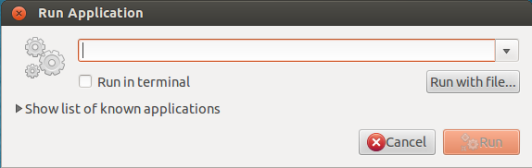
- type “gksu nautilus” (without the quotes) and press enter
- you are asked for your password. Enter it; a Nautilus window will appear.
Be VERY careful when moving or copying files around! It is easy to damage the system if you accidentally move some things out of place.
Any program you start from this Nautilus window will also run with full privileges! For example, opening a text file from the file manager will also make the editor it is opened with run with all privileges. As such, you can edit system files such as the configuration files in /etc. Be very careful! These files are needed for normal operation of the system! If you can get the job done by running programs as your normal administrator user, do so!

Restoring a failed server
This documents the procedure to be followed in case the network computer is damaged in such a way that it can not start anymore, or if the configuration is lost beyond repair.
IMPORTANT NOTICE: this procedure should only be started in case of extreme problems and if all other methods to get the server back in a working state have failed!

Computer damaged
Make a note on how the disk drives are put in the system (which drive at which connector on the motherboard) and place the disks in the same way in a replacement system. Since all PC's in the room are essentially the same hardware configuration except for the size of the disk drives, they can make a replacement computer.
If the hard disk are in a good state, the system will start as it did before.

Restore system partitions
The servers are configured with hard drives in raid-1. This means that if one of these drives is broken and fails, the server will still run and the data and operating system are still in place and working. In rare circumstances (irreparable damaging of the server software, the system refuses to start, acidental removal or altering of essential system files,...) it is possible to restore the entire system to the state it was in when the system was first installed.
A system can be relatively easy restored to its original state; your data, on the other hand, are precious. The most important thing to take care of is to make sure your data will not be overwritten in the process!
Proceed as follows:
- Check the status of your backups using the procedure described in the section“Maintenance: checking status of backups ” on page 11. If you don't have a recent backup (same day or day before), perform one now and ensure it succeeded.
- put the clonezilla usb pen drive in a usb slot at the back of the server. Make sure you have the correct one: we provide one for the backup server and one for the file server.
- Start or restart the server.
- You should see the clonezilla boot screen; just take the first option.
- Choose the appropriate language and keyboard layout; you can select “leave keymap untouched” for US qwerty keyboards, or for another layout you can select the option “choose select keyboard layout from arch list”.
- Perform a “device-image” operation.
- As source, choose “local_dev”.
- Choose “restoreparts”. Watch out: do NOT choose “restoredisk”!
- From each disk, you will see that there are several partions. One partition on one disk will have a counterpart of the same size on the other disk.
  - On the fileserver, there are 4 partitions per disk; in the backup server, there are 3 partitions per disk, which are equal in size pair by pair. See the “General reference ” section for exact details.
  - WARNING: most of both disks are taken up by the biggest partition, which holds all the data. It is important that you do not overwrite this partition!
- To restore just the system, select the partition on both disks which is (rounded) 20 GB in size. It is important to select this partition for BOTH disks!
- Start the restore. When Clonezilla is done, your system will reboot into the state it was the day the system was installed.
After re-installing, all customisations made to the system after installation will be lost. This includes created users, or possible new shares. You will have to configure them again, but your data (/home partition) should still be intact and still contain data as before the system restore procedure.

Full restore
In worse conditions (the hard disks were both damaged and had to be replaced) there is no other option than to restore the entire installation from the beginning. This procedure will overwrite the entire disks including your data partition. After this, you will have to use the procedure for restoring your backup on page 12.
Proceed as follows:
- Check the status of your backups using the procedure described in the section“Maintenance: checking status of backups ” on page 11. If you don't have a recent backup (same day or day before), perform one now and ensure it succeeded.
- put the clonezilla usb pen drive in a usb slot at the back of the server. Make sure you have the correct one: we provide one for the backup server and one for the file server.
- Start or restart the server.
- You should see the clonezilla boot screen; just take the first option.
- Choose the appropriate language and keyboard layout; you can select “leave keymap untouched” for US qwerty keyboqrds, or for another layout you can select the option “choose select keyboard layout from arch list”.
- Perform a “device-image” operation.
- As source, choose “local_dev”.
- Choose “restoredisk”.
- From each disk, you will see that there are several partions. One partition on one disk will have a counterpart of the same size on the other disk.
  - On the fileserver, there are 4 partitions per disk; in the backup server, there are 3 partitions per disk, which are equal in size pair by pair. See the “General reference ” section for exact details.
  - WARNING: most of both disks are taken up by the biggest partition, which holds all the data. It is important that you do not overwrite this partition!
- Start the restore. Restore BOTH disks and every partition on it.When Clonezilla is done, your system will reboot into the state it was the day the system was installed.
- After re-installing, all customisations made to the system after installation will be lost. This includes created users, or possible new shares. You will have to configure them again, and even your data (/home) partition will be empty again. So use this restore method only as a last resort!

Windows virtual machine is broken.
In case VirtualBox is working, but there is a problem with the virtual machine, you can restore the virtual machine in its original state. Watch out: this is only the right solution if Virtualbox itself is still functioning properly, but there is a problem in the virtual machine.
Virtual machines have the huge advantage that they can be deleted, copied, and recreated whenever it is practical to do so. VirtualBox has a function to “export” a virtual machine, which can then be carried for example to another computer and imported there. We saved an exported virtual machine in the teachers Documents folder, which is in the state that we delivered the whole system.
To import this virtual machine, proceed like this:
- open VirtualBox.
- Go to “file”, then “import appliance”.
- Click “choose” and point to the big file in “Documents” called “virtualwin-teacher.ova”. Importing will take a LONG time.
- Start the new virtual machine.
- Optionally: change the host name to yourschoolname-vwin. (We've chosen “vwin” to signify that it is a Virtual WINdows machine).
- If it works well, you can delete the old one (from within VirtualBox, not using the file manager!)

Error checklist
A number of things that can be checked in case a problem of any sort arises.

Problem accessing the internet
TODO
Problem: web site does not show up, error in web browser, stating that the program can not connect to the internet; for example:
- “The proxy server is refusing connections”
- error: the requested url could not be retrieved, with a logo picturing a squid.
  - the domain name does not exist
  - unable to determine IP address from host name “www.website-which-does-not-exist.com”

Possible sources of error:
- network problem (disconnected,...)
- router misconfigured
- proxy server not running
- proxy unable to access the internet

Problem with network share
Problem: can't access a network share, error when reading file, error when writing file, error when deleting file
Possible sources of error:
- network problem (disconnected,...)
- password problem
- disk full
- a configuration error

Possible source of error: network problem
Use “ping” to test if you can reach the file server:
- open a command line in Windows (start → run → type “cmd” (without the quotes)
- type: “ping 191.168.0.11”. You should see a message telling you that the connection succeeded, like this:
  - 64 bytes from 192.168.0.11: icmp_req=1 ttl=64 time=0.621 ms
  - On the servers (which are running Linux) you can use this program to test: Applications → System Tools → Network Tools – tab sheet “ping”.
“ping” tests the network by sending a network packet to an other computer. If there is a reply, the network connection works. Any else than the message above, such as no reply, a delay of more than a second (see the value behind “time=”) may indicate a network problem.

Possible source of error: password problem
- Check if the user exists in the system: see “create a user”
- use the system-config-samba tool to reset his/her password. If this solved the problem, the network password was incorrect.

Possible source of error: full disk
Sooner or later, you may run out of disk space on the fileserver. Very often, most space is consumed by a small number of very large files. You could do this from a Windows PC by inspecting the properties of various folders in the shared drive, or the administrator can also do it on the server.
- Open the file manager (“places” in the menu bar),
- click one of the “devices” on the left
- check the status bar (bottom of the window): it shows how much space is left. To be safe, this should be a few GB at least.
- Repeat for all items under “devices”.
To check where the most space is used:
- To find which folder contains the most data, you can use the program “baobab”. It is in the applications menu under “system tools” → “diskusage analyzer”. This is useful to analyze the space usage of your own data.

Possible source of error: configuration broken
If a certain problem showed up after changing a part of the configuration, chances are they are related. The Samba configuration program is capable not only of setting the password of network users, but also of modifying the entire configuration. For this reason, we have provided a safe copy of the most important system configuration files in the Documents folder of the administrator user on the fileserver.
The network sharing service (Samba), has one important configuration file called smb.conf, which you may choose to copy back to its original location in /etc/samba. You may, off course, also choose to make a safe copy of the file before you overwrite it with the original.

router misconfigured
TODO

proxy unable to access the internet
TODO

proxy server not running
TODO

Backup failed
What happens if a backup started running, but does not succeed?
A backup has failed if the backup has ran, but has not rotated the “daily.<n>” folders: the latest snapshot, daily.0, still has the same data and time as before the failed backup attempt and there is a folder called “rsync.tmp” still present. (See “how backups work”, page 7).
The possible problem is in one of two categories.
- The backup has encountered an error, such as a network error, authentication error, an unreadable file on the file server, or a full disk. It has exited with an error and has not rotated the snapshots. You can find more details in the log file inside the “backup” folder. Try solving the problem and restarting the backup.
- The backup process was interrupted. For example: the backup server system was turned off before the backup could complete, or the backup process was forcibly stopped.
In this case, you will find a file called “LOCK” inside the rsync.tmp folder. If this file exists, the backup script will refuse to start another backup! This is a protection method for not writing two backups to the same folder at the same time. If the LOCK file is still there and the backup is not running anymore, this means that it did not get the chance to remove it before the script stopped.
See the next section on how to solve this situation.

Backup still running or killed, and how to solve
In the previous section, we described the symptoms you might encounter when a backup fails, and hasn't had the change to exit cleanly. For solving this problem and to be able to create a new backup again, follow these stept:
- Check if the backup actually crashed, or if it is simply still running. Use a task manager as described under the section “Maintenance: checking status of backups ” on page 11.
- If the backup is still running, simply wait. Eventually it will either succeed, or time out and fail (in which case you can find out why it has by reading the log file).
- If it is not running, you may delete the file “LOCK” inside rsync.tmp.
You should now be able to start a backup once again.

Backup failed: no more disk space
In case there is not enough space left on the backup server to create a new backup, you maybe able to solve the problem by deleting your oldest backup. See section “How backups work” on page 7 to identify it.
A word of warning:
- Be sure to remove either the entire old backup folder, or nothing! Restoring from a half backup is confusing.
- Just moving to the trash can is not enough! The files in the trash can still occupy space.
You may also want to tweak the settings maxdaily, maxweekly and maxmonthly in the backups settings file to a more suitable number. You will find this file on the desktop, it is named “dhunkharka-backup.cfg”. The gedit text editor will be able to open it.

Failed hard drive
Your systems are installed on a raid-1 array. That means there are two hard drives with identical content. If one hard drive fails, the other will still work and your system will continue working. (Moreover, raid-1 ensures that files can be read from the hard disk almost twice as fast).
If a hard disk fails, you only have one functioning drive left. This means that if the remaining drive one day also fails, your system will not work anymore. Therefor, you should replace the broken disk with a new one.
Once the disk is physically installed in the server and properly connected, it will be visible in the Disk Utility (Application Menu → System Tools → Preferences → Disk Utility). In each server, a few raid volumes are defined. Each of these are based on a partition on each of the two drives in the system.
One way to do this is:
- take the old drive out of the system and add a new one
- with the disk utility, create a new, empty partition table on the new drive
- use the disk utility, and for each of the degraded arrays, click “edit components”, then “add spare”, and indicate your new drive when given the choice. The utility will add a new partion on the new drive, add it as a spare and immediately use it to replace the partion of the failed drive which had been removed.
Another way is more difficult, but may help out if you run into trouble with Disk Utility:
- take the old drive out of the system and add a new one
- copy the partition table from the GOOD drive to the NEW drive using this command:
sudo sfdisk -d /dev/<good> | sudo sfdisk /dev/<new>
your hard disks are called /dev/sda and /dev/sdb. Be sure you are certain about the name of the good drive and that of the new drive! Doing this the other way around results in irreparable data loss.
- reboot the system to be sure the system knows about the newly created partition table.
- Figure out which partitions should be added to which array by looking at the Disk Utility or by entering:
cat /proc/mdstat
Partitions' names are the name of their hard drive, plus a number. For example: /dev/sda4, or /dev/sdb8.
/proc/mdstat normally looks like this:
Personalities : [linear] [multipath] [raid0] [raid1] [raid6] [raid5] [raid4] [raid10]
md2 : active raid1 sda6[0] sdb6[2]
19528632 blocks super 1.2 [2/2] [UU]

md0 : active raid1 sda5[0]
1950708 blocks super 1.2 [2/1] [U_]

md127 : active raid1 sdb7[1] sda7[0]
458845760 blocks super 1.2 [2/2] [UU]
[==============>......] resync = 71.9% (330333952/458845760) finish=22.7min speed=94334K/sec

unused devices: <none>
In the example above, /dev/md2 is healthy, /dev/md0 is degraded (bad state!) and /dev/md127 is resyncing (recovering).
The raid device /dev/md0 is created using /dev/sda5, and it does not have a second partion anymore. Since the partition tables on both disks are copied identically, you need the equivalent partition number on the new disk to add to the array (in this case: /dev/sdb5).
- For each of the partitions 5, 6, 7 and 8, run this command:
sudo mdadm --zero-superblock /dev/<new><n>.
You may get an error that looks like this: “mdadm: Unrecognised md component device - /dev/sdb1”. It can safely be ignored.
- You need to add the partitions as a spare to their appropriate raid arrays. Above, you can see that the array “md0” is created from /dev/sda5 and /dev/sdb5. If /dev/sda5 were on your working disk and /dev/sdb5 on your new disk, you would have to issue the following command:
sudo mdadm /dev/md0 –-add /dev/sdb5
Substitute /dev/sdb5 for the appropriate partition on your new disk.
- after this the raid array will resync. (You can see above that /dev/md127 is resyncing). You can monitor the progress using Disk Utility or by running
cat /proc/mdstat
- again. When resyncing is done, you must install the boot loader on the new drive (making your server able to start from the drive):
sudo grub-install /dev/<new>

General reference
This section is meant as the collection of settings and system information. It does not provide an explenation on how to enable these or perform tasks, but it enables you to quickly find pieces of information when needed.

Network
Names and Adresses:
- Network range: 192.168.123.0/16
- Gateway: 192.168.123.254
- Server:
  - host name is composed as such: the name of your school + -lin1. For example: “sharada-lin1” or “chamaladevi-lin1”.
  - IP address: 192.168.123.10
- Clients (PC's): will be in the range 192.168.123.0/24. The addresses are not fixed.
  - host name: will be like schoolname-win1, schoolname-win2,...
- Thin clients: have the same non-fixed addresses, but they generate the host names themselves (it will be only a number).
Which parts of the configuration are relevant to network addresses?
- network configuration, see the section “Changing the network configuration” on page 12.
- A bookmark for the Rachel server should be easyli accessible for students. You may want to create a desktop icon, a start menu icon, of a bookmark in the web browser pointin
- the file “dhunkharka-backup.cfg” in the administrator's “Documents” folder on the backup server (address of the file server), because the backup server needs to know the name of the file server.
- The proxy address in the users' web browsers

Operating systems
- server: Ubuntu 12.4 LTS with Gnome desktop
- PC's: Windows 7 desktop

Server Installation
Reference on the choices made when installing the operating system on the servers. In normal circumstances, you will never need this information. It is purely here as a memory aid.
- Country/area: Nepal
- “locale” settings: based on United States
- keyboard: English (US)
- Network: configure manually (see page 23)
- The first user of the system (the one with full privileges) is called “administrator”.
- Encrypt home directory: no
- ntp: will be set up to Ubuntu's default settings. Installed ntpd.
- Installed devanagari fonts

Server installation: specific to file server
Two hard drives of 500GB are configured.
Partitioning:
RAID: four software raid devices are defined; these are comprised of sda5, sda6, sda7, sda8 and sdb5, sdb6, sdb7, sda8 respectively.
The four resulting raid devices are used as follows:
- swap partition 2 GB, ext4
- root (/) partition 20 GB, ext4, labeled “system”
- user files partition (/home), 450 GB, ext4, labeled “home”
- proxy server files disk (/var/spool/squid): the rest of the disk, which is about 28 GB (ext4, ), labeled “squid”, mount option “noatime”
The raid system is configured to still start the system if one of the disks has failed.

Server installation: specific to backup server
Two hard drives of 500GB are configured.
Partitioning:
RAID: four software raid devices are defined; these are comprised of sda5, sda6, sda7 and sdb5, sdb6, sdb7 respectively.
The four resulting raid devices are used as follows:
- swap partition 2 GB, ext4
- root (/) partition 20 GB, ext4, labeled “system”
- user files partition (/home), 450 GB, ext4, labeled “home”
- proxy server files disk (/var/spool/squid3): the rest of the disk, which is about 28 GB (ext4, ), labeled “squid”, mount option “noatime”
The raid system is configured to still start the system if one of the disks has failed.

After installation modifications
The default desktop environment has a look and feel that may be more at home on a smart phone. Therefor we have also installed a more “classic” desktop (by installing “gnome-session-fallback” from the software center). You can access either by clicking on the foot icon next to your user name (“administrator”) and selecting “Gnome classic”.
Extra packages we have installed:
- gnome-session-fallback
- extra language support: Nepali
- “secure shell client and server (metapackage)”. This allows logging in from another system in a safe way (but this is command line only). It is a very powerful, although hard to learn tool. In normal circumstances you do not need to use it directly, but the backup script uses it to log in to the file server.
- rsync, a powerful file copy tool
- samba (in the software center: “SMB/CIFS file, print, and login server for Unix”), needed for sharing files with Windows PC's plus “libpam-smbpass” allowing password synchronisation between the Linux operating system and the Samba file server
- gnome-system-tools, for a better user administration tool
- System-config-samba: a small but useful tool for doing the most necessary things in the Samba file server.
- Squid, the proxy server
- The MySQL database server and the Apache web server, used by the search engine inside Rachel
- The PHP programming language
- Virtualbox, a software that allows a complete simulation of a computer on top of your Linux desktop. You can use this to run MS-Windows inside your Linux PC!
- Some practical tools for the Linux command line, such as Vim and Git
- Language support for Nepali
- … and numerous educational tools!

File server configuration
Created a shared folder. This was done by using a text editor to edit /etc/samba/smb.conf, which is the main configuration file for Samba. If you ever make changes to the configuration (using for example system-config-samba, the configuration tool in “applications” → “system tools” → “administration” → “samba”), it is advisable to first create a safe copy of this file. (In fact, we already provided one in the teacher's “Documents” folder on the file server).

